Monitoring your AWS costs
All AWS services are a pay-as-you-go service, so we urge our students to closely monitor their usage costs and if they have adequate credits available to complete their project/task. Follow the instructions below to do that:

Step 1. Log into your AWS account.

Step 2. Examine your costs
Go to https://console.aws.amazon.com/billing/
You should see the following billing dashboard where it will show your costs.

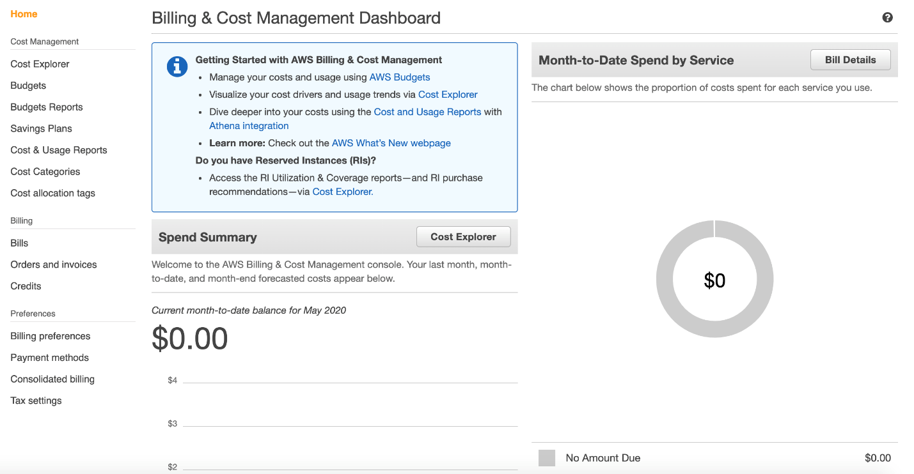

Step 3 (optional). Check the value of your credits.
Click on the "Credits" from the left side menu and the following screen will show with your available credits.

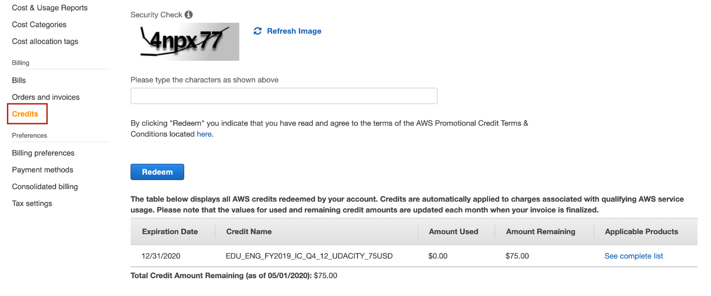

Note: For student learning, Udacity has partnered with Amazon to provide nominal credits for the student to complete their course work. Please understand that these credits are limited and available for you to use judiciously. You are responsible for any additional costs beyond the given credits.

Shut Down your Endpoints, if not in use

Note: We recommend you shut down every resource (e.g., EC2 instances, or any other hosted service) on the AWS cloud immediately after the usage, otherwise you will run out of your free promo credits.
Remember, even if you are in the middle of the project and need to step away, PLEASE SHUT DOWN YOUR ENDPOINTS. You can re-instantiate later.

